**Assignment 1: Automated Instance Management Using AWS Lambda and Boto3**

Create two EC2 instances:

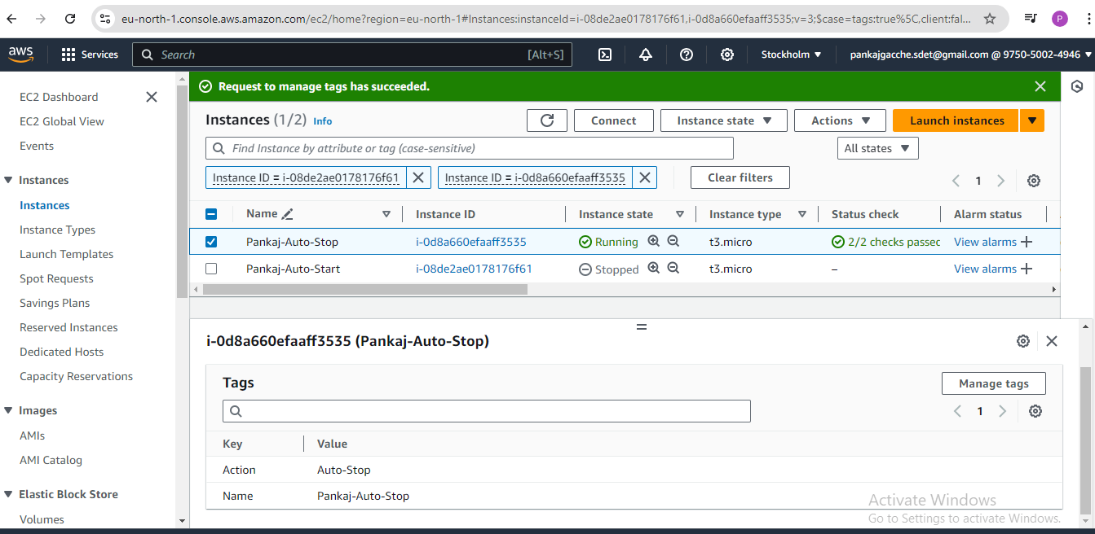

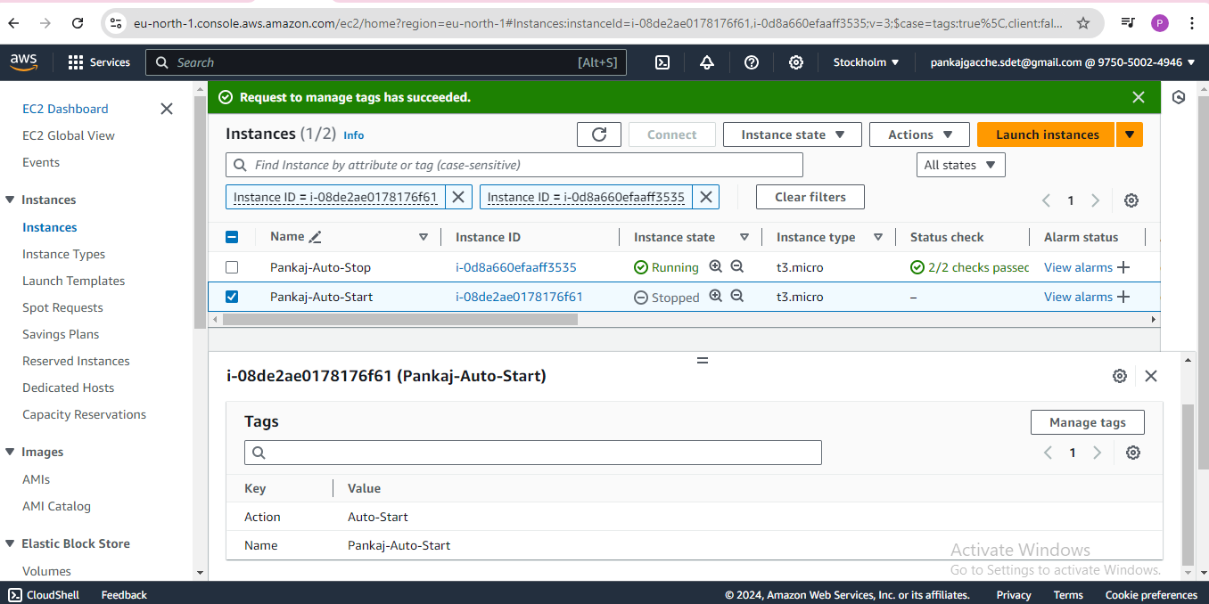

IAM permissions to describe, stop, and start EC2 instances:

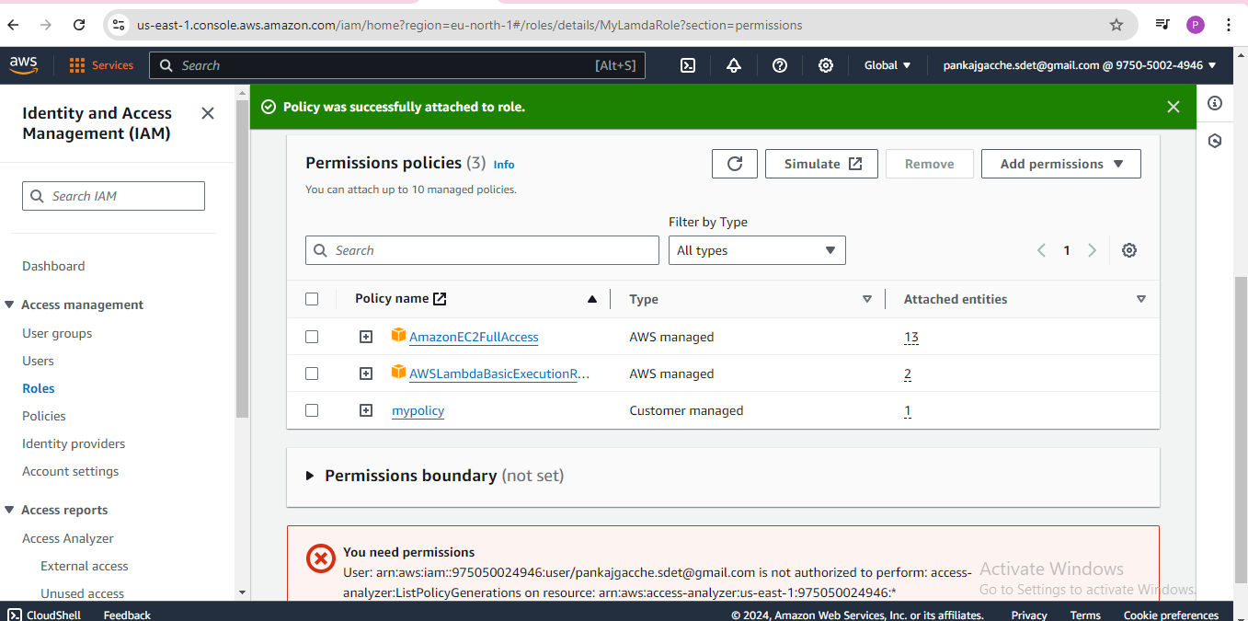

Set up an AWS Lambda function:

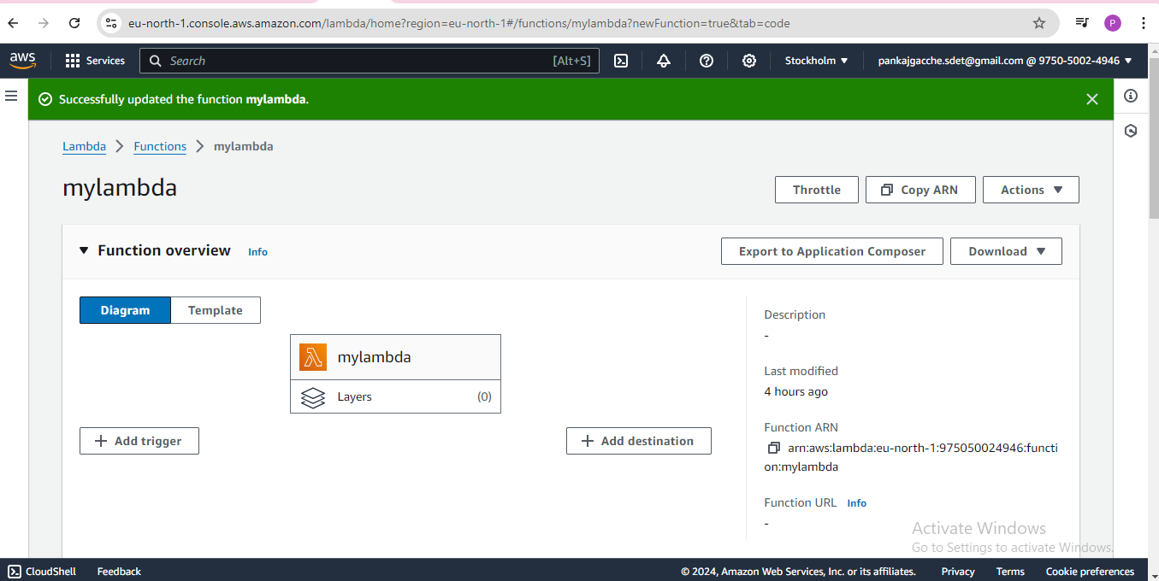

Using Boto3 in the Lambda function:

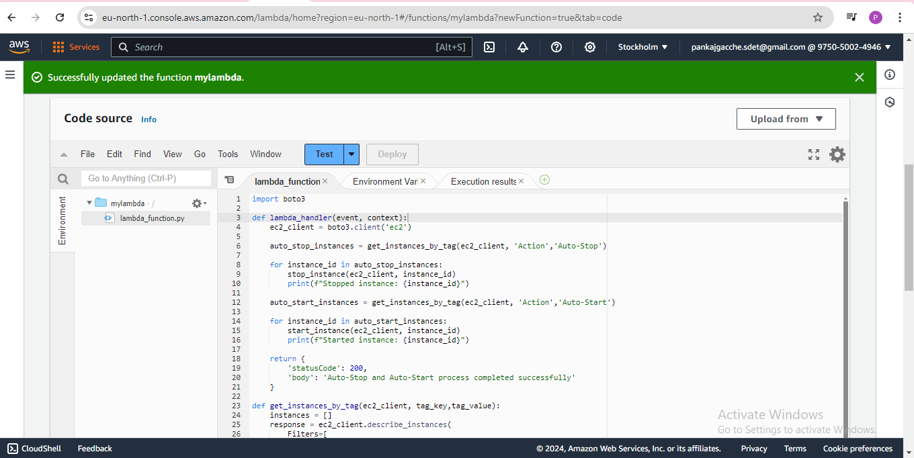

Manually invoke the Lambda function:

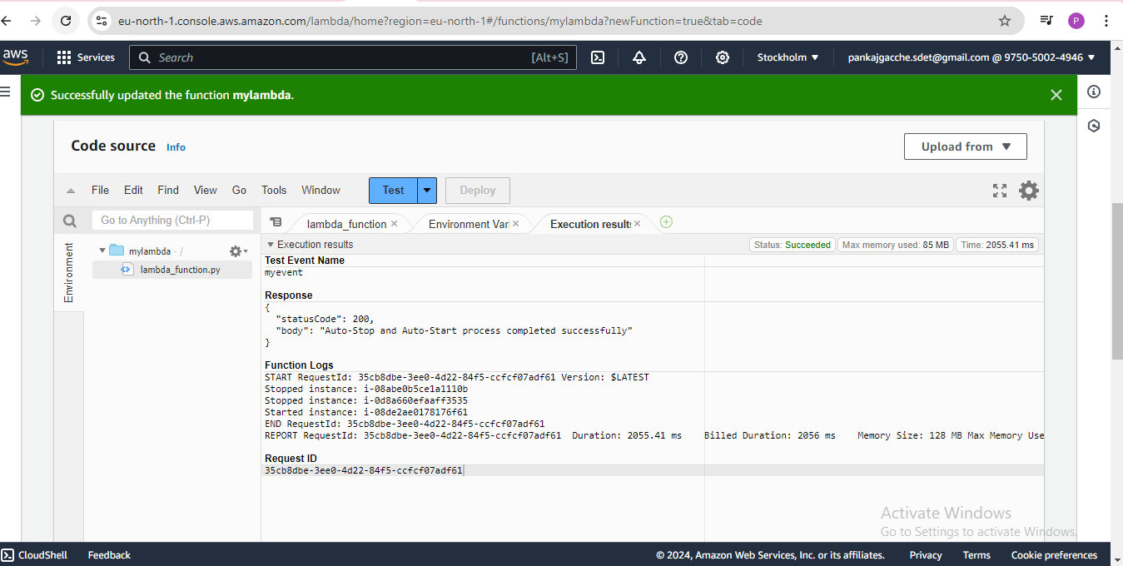

Confirm that the instance tagged `Auto-Stop` stops and the one tagged `Auto-Start` starts:  
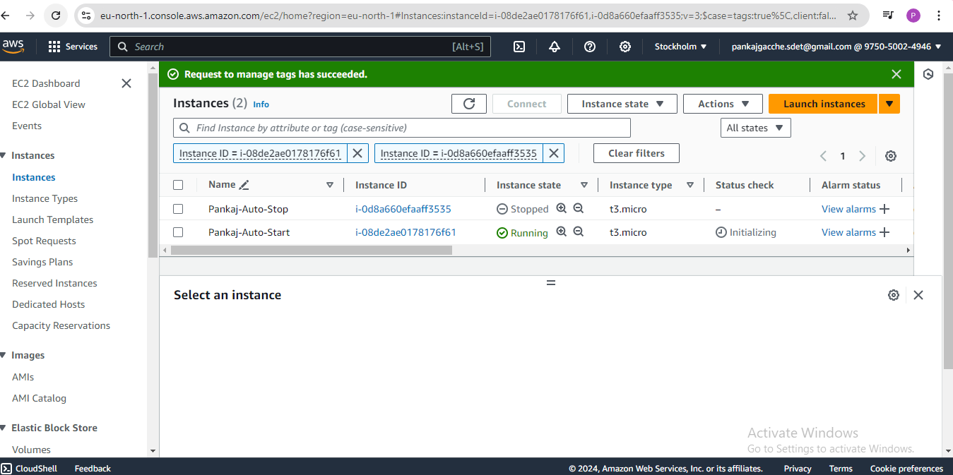

**Assignment 2: Automated S3 Bucket Cleanup Using AWS Lambda and Boto3**

Created a new S3 bucket:

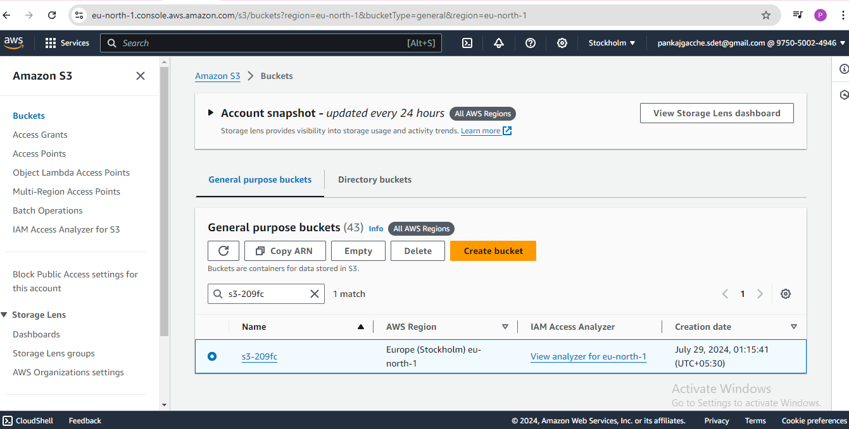

Upload multiple files to this bucket, ensuring that some files are older than 30 days:

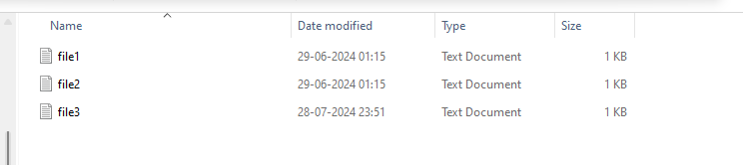

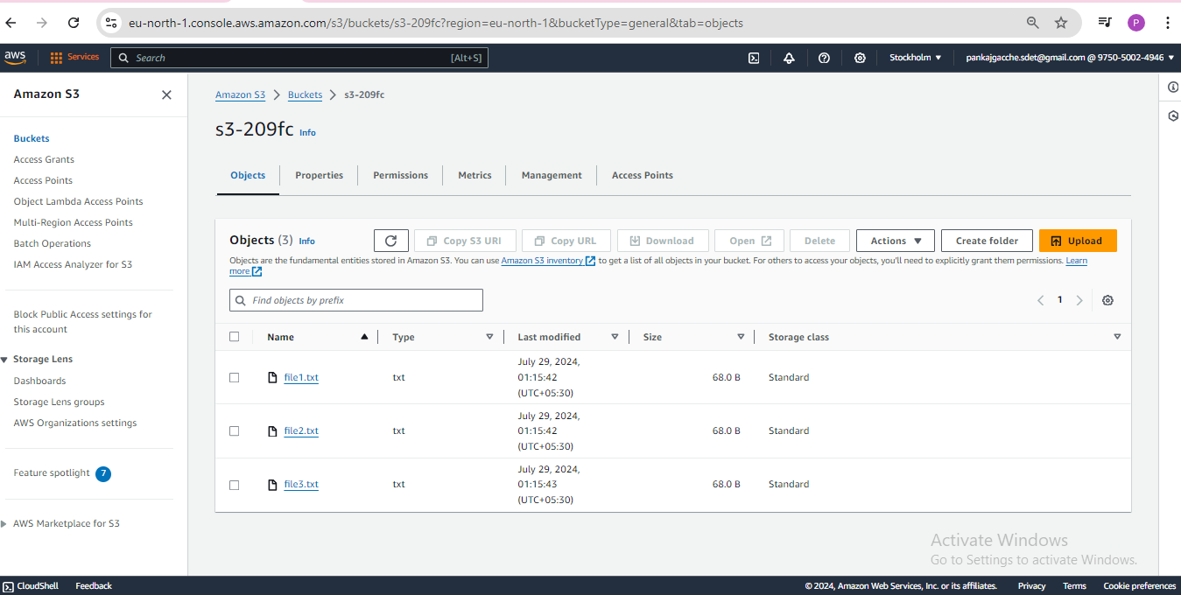

Lambda IAM Role for S3 bucket:

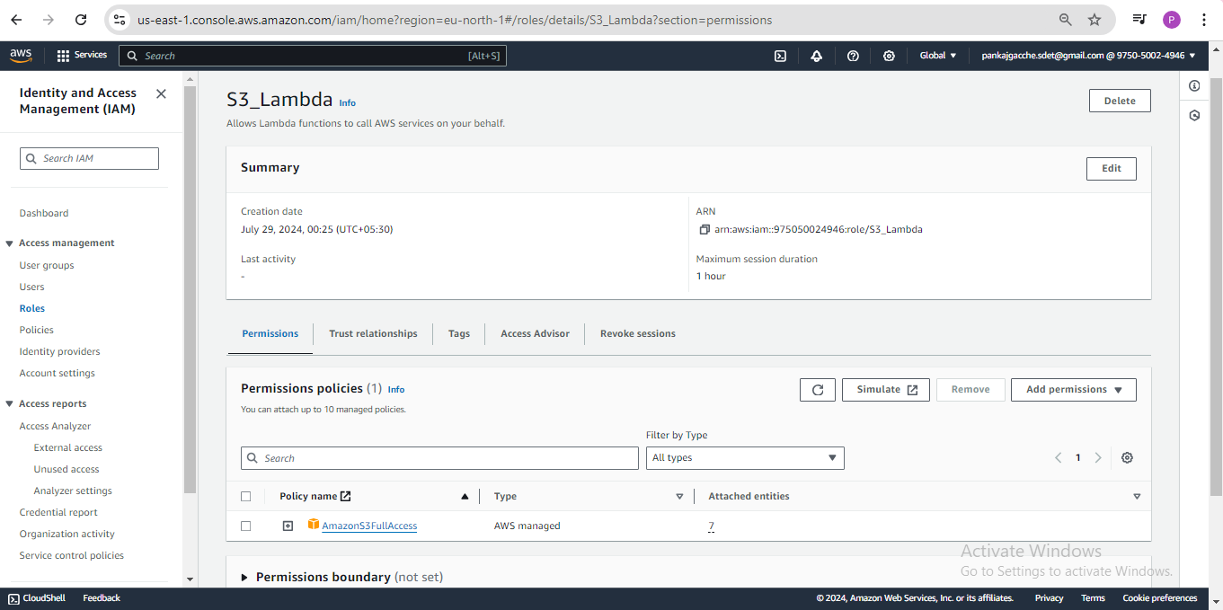

Lambda Function:

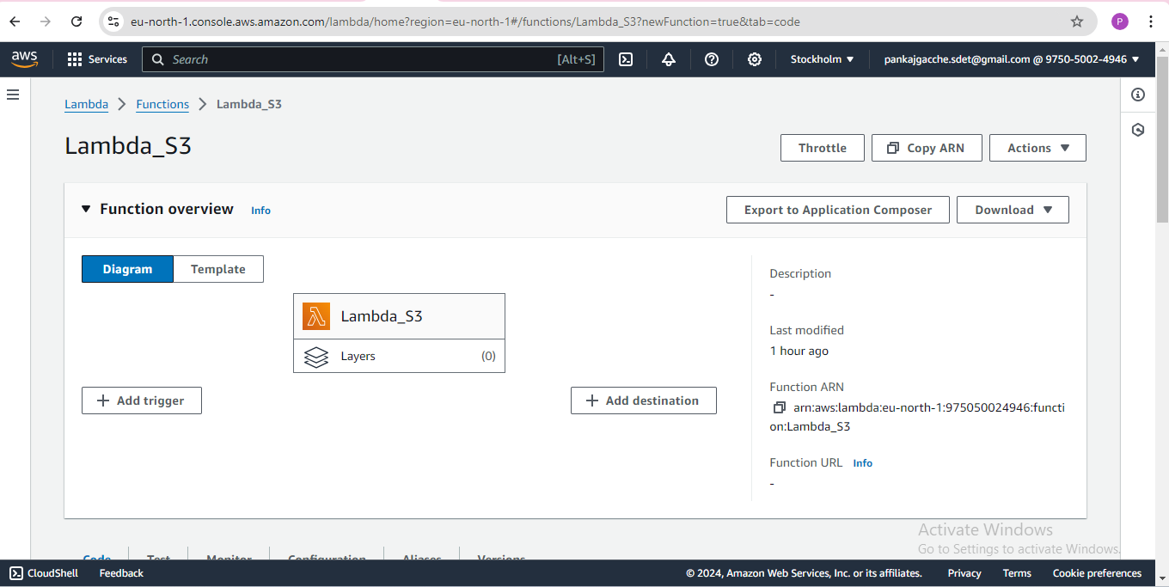

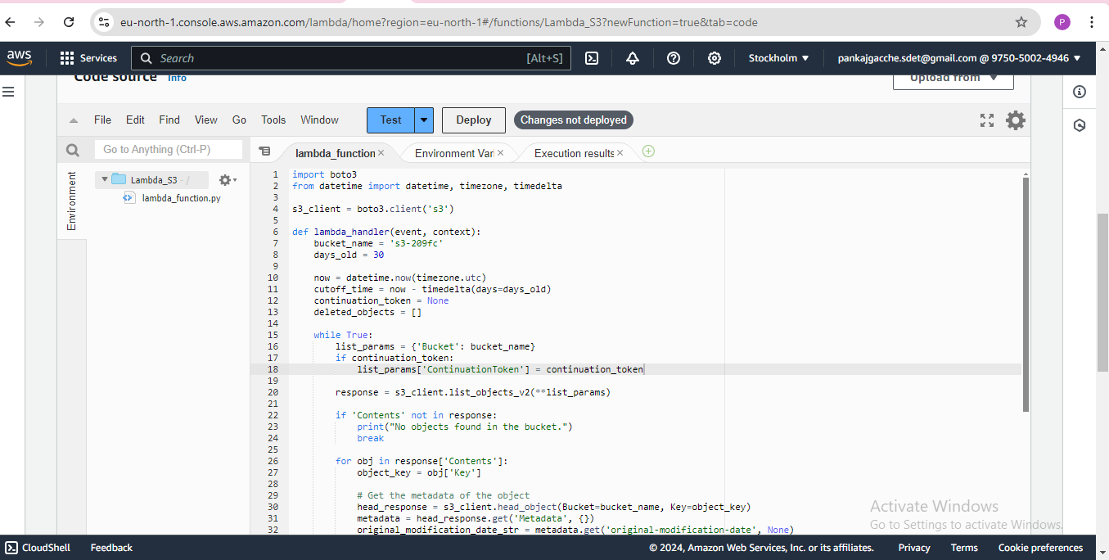

Deleted objects older than 30 days:

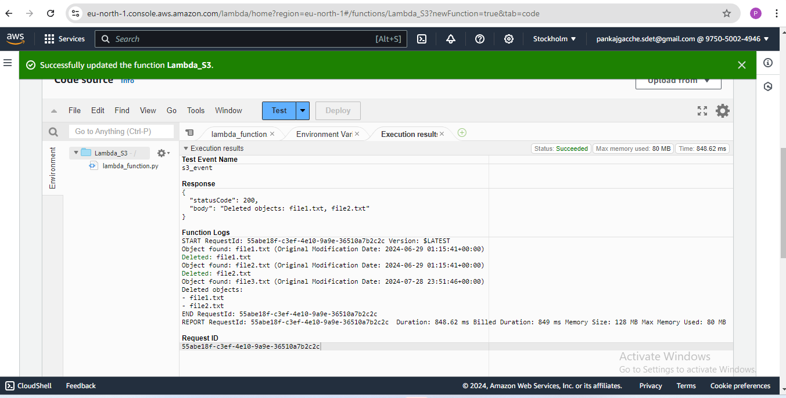

Navigated S3 dashboard and confirm that only files newer than 30 days remain:

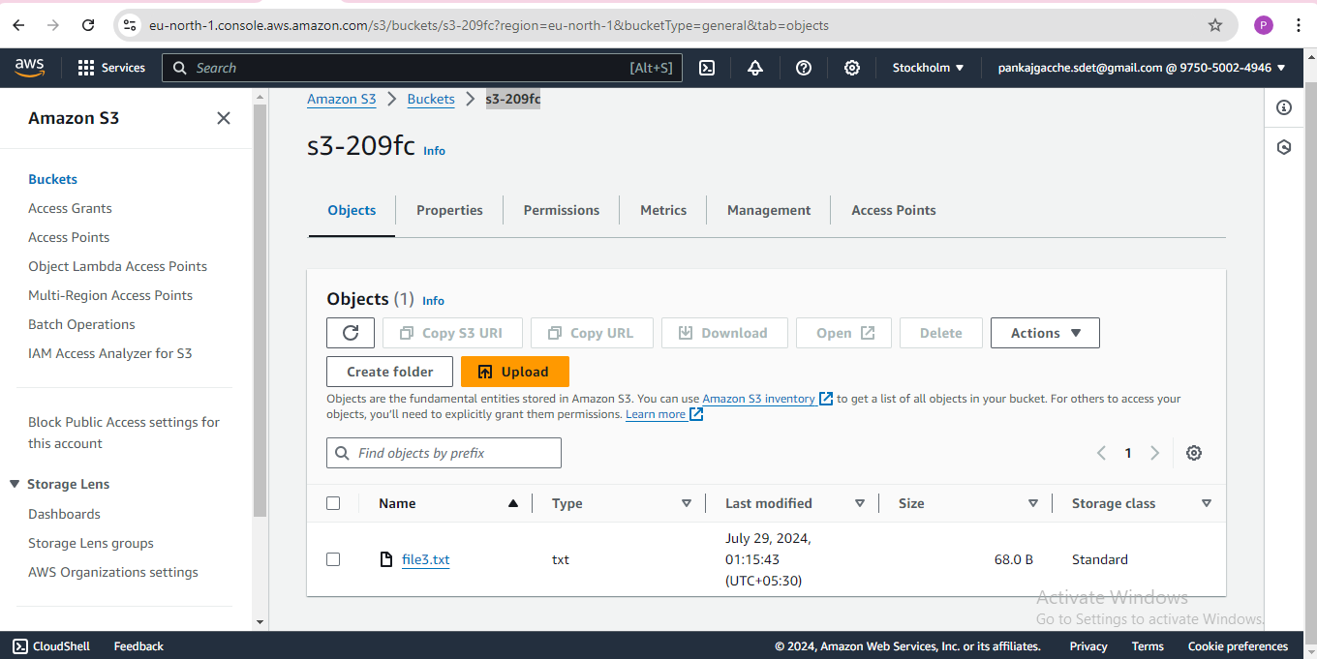

**Assignment 3: Monitor Unencrypted S3 Buckets Using AWS Lambda and Boto3**

Navigate to the S3 dashboard and create a few buckets:

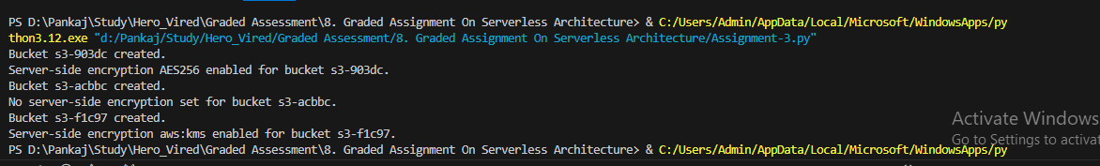

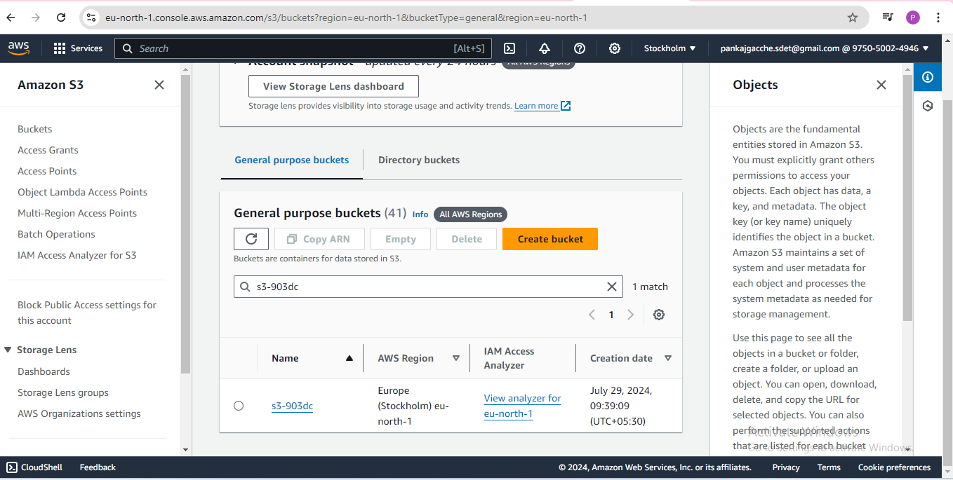

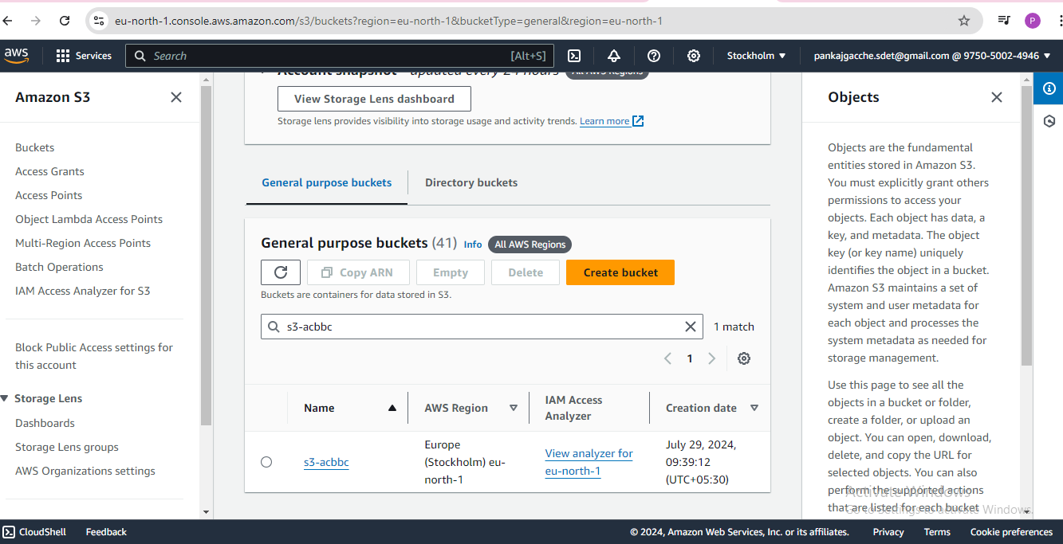

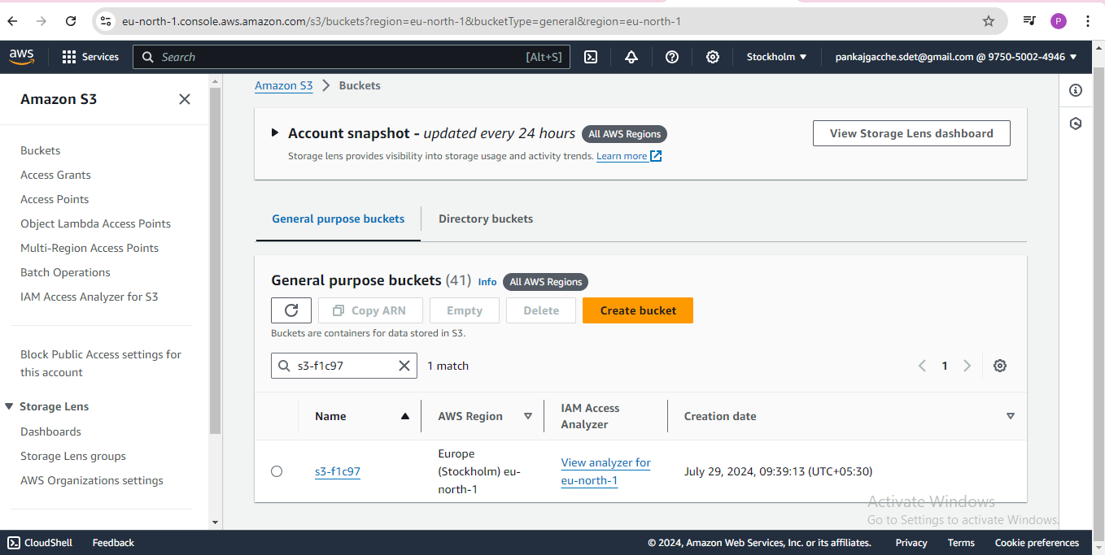

Created Lambda IAM Role:

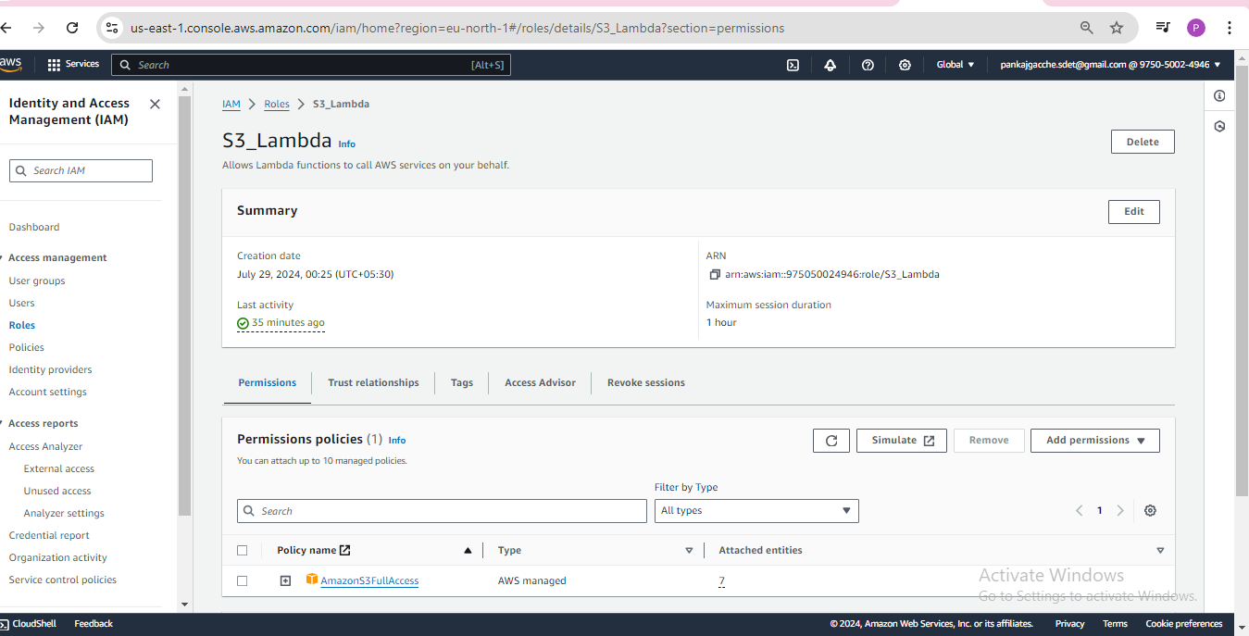

Created Lambda Function:

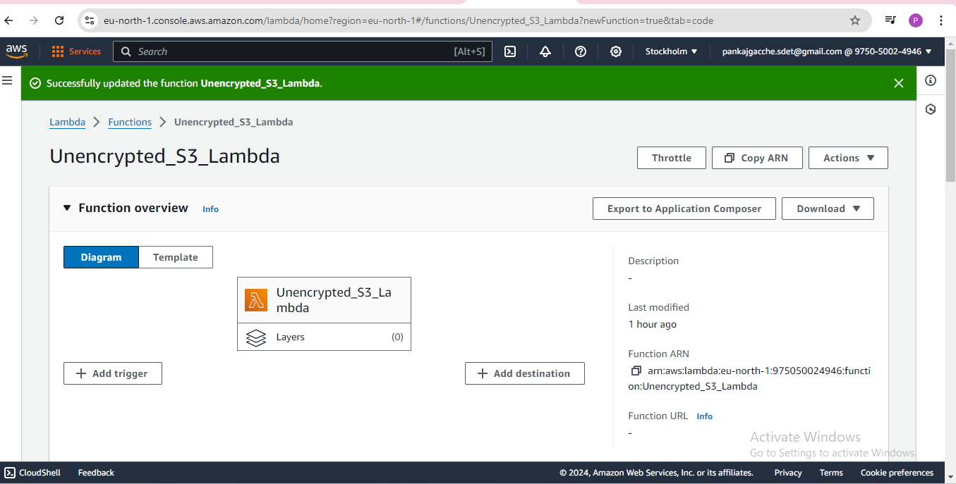

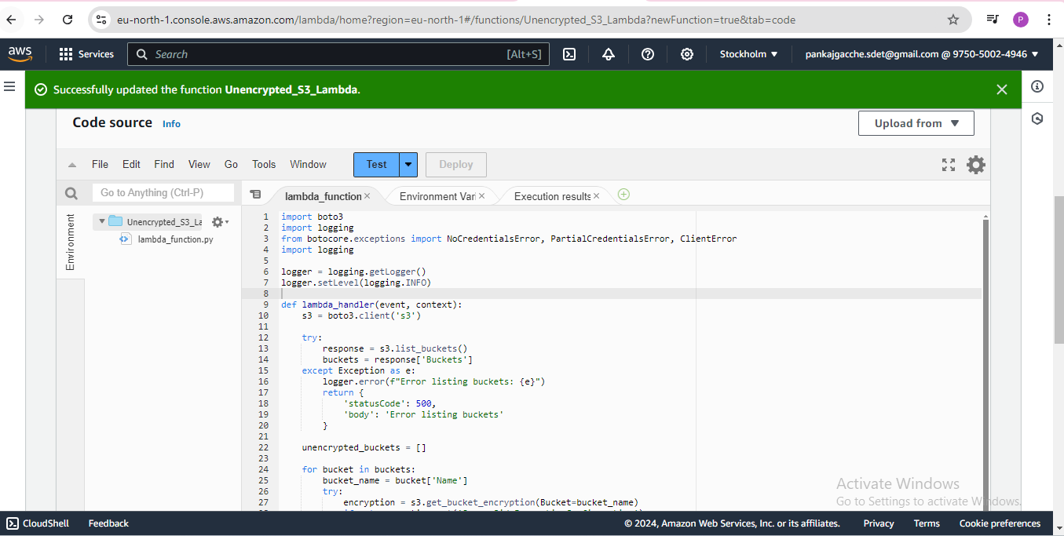

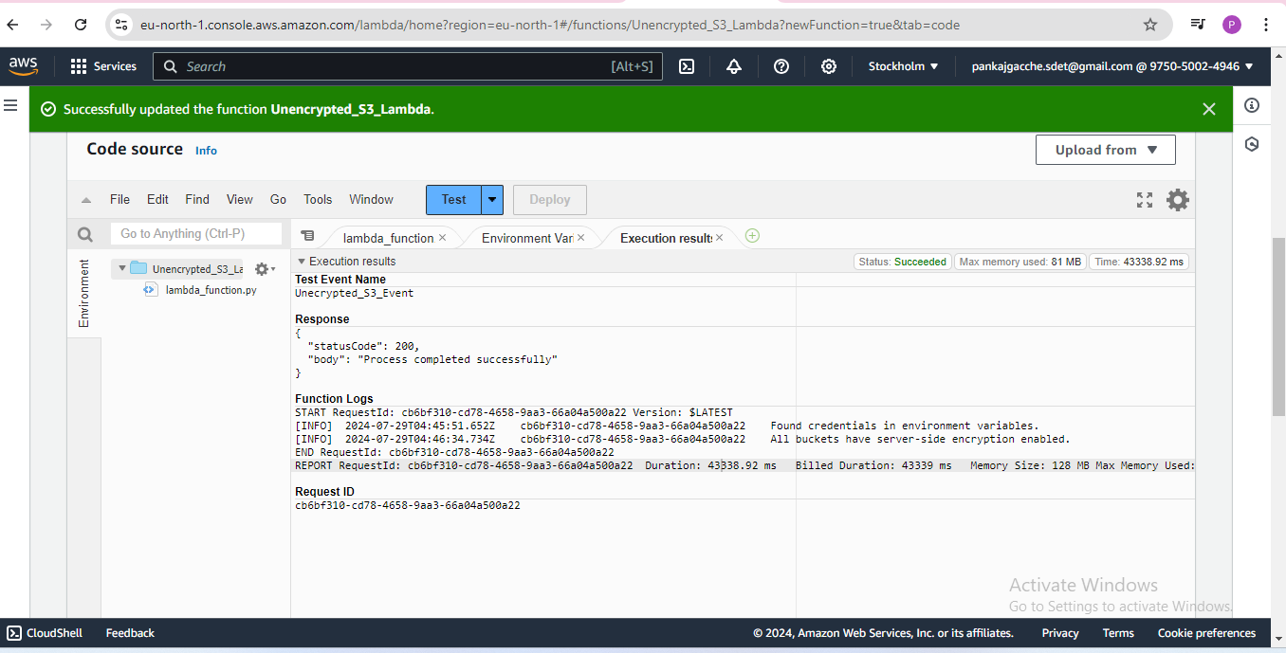

**Assignment 4: Automatic EBS Snapshot and Clean up Using AWS Lambda and Boto3**

Navigated to the EC2 dashboard and identified EBS volume:

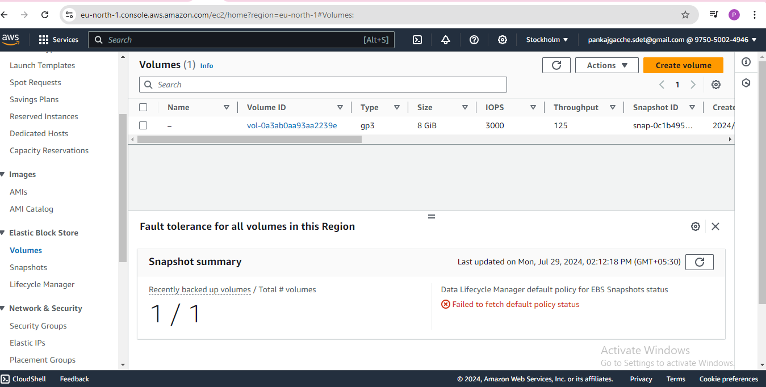

Created Lambda IAM Role:

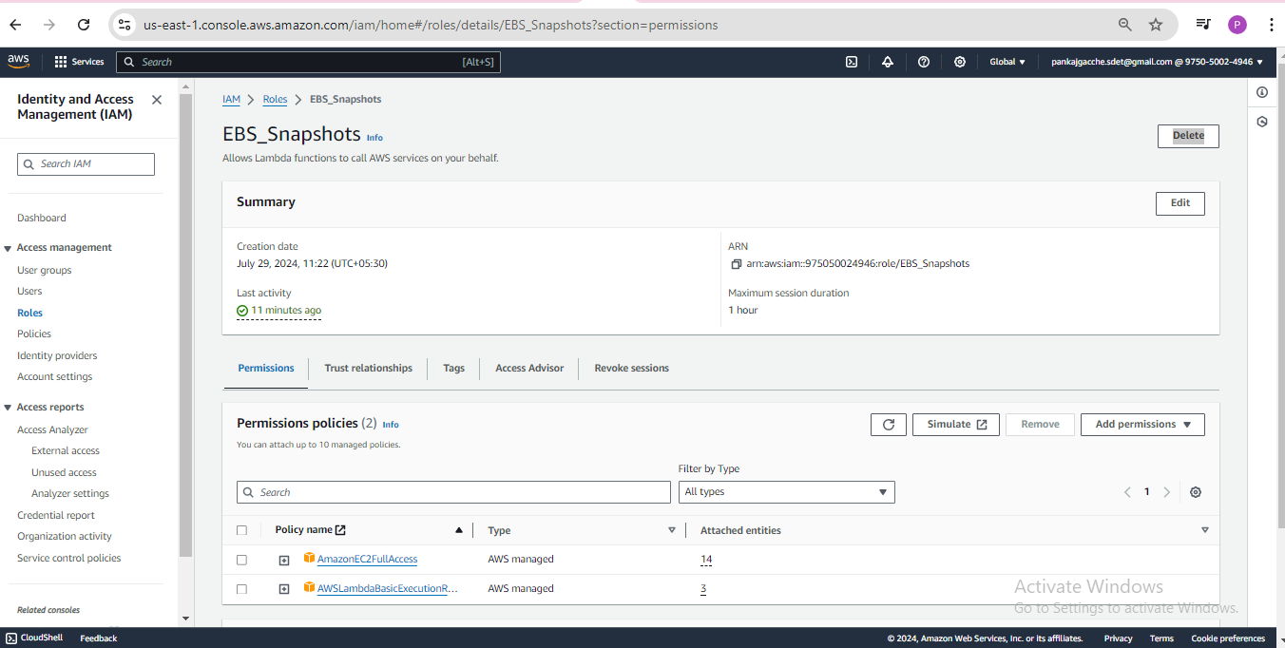

Created Lambda Function:

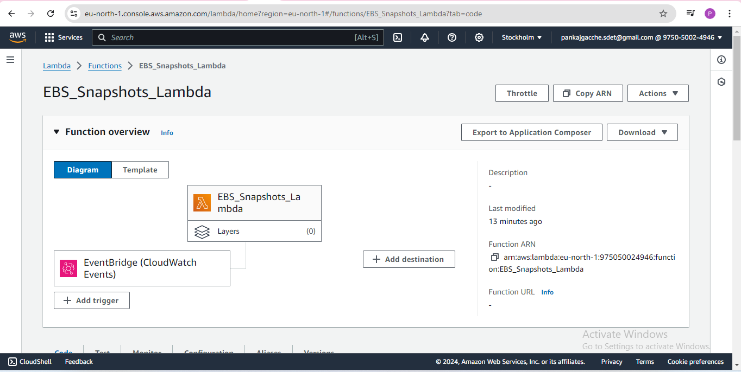

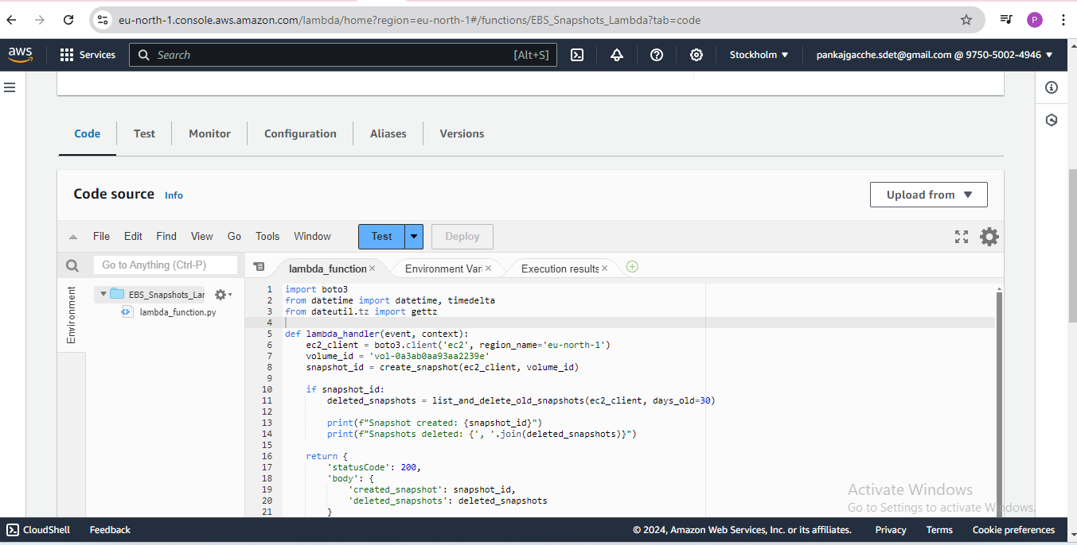

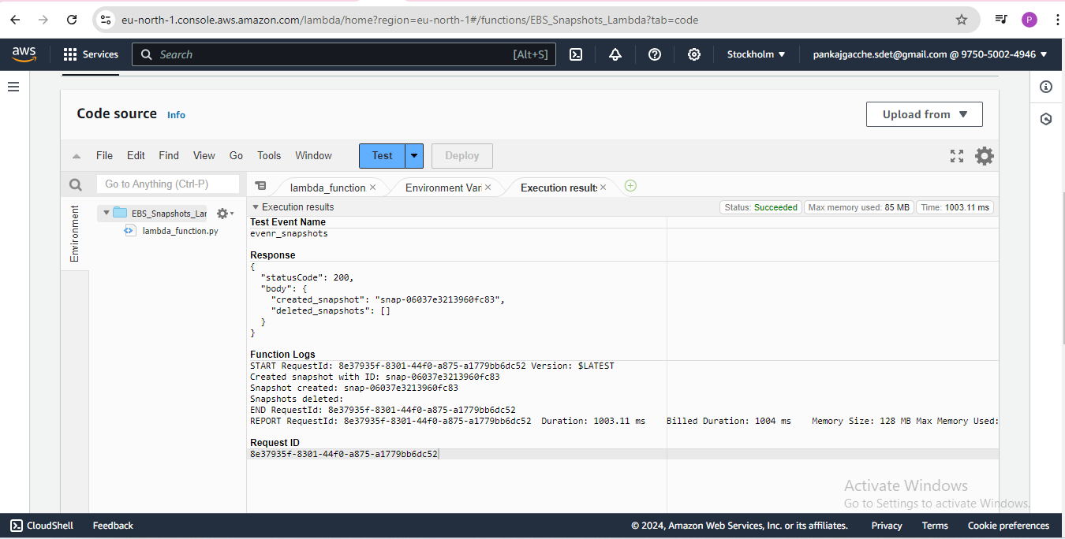

Attach an event source, like Amazon Cloud Watch Events, to trigger the Lambda function

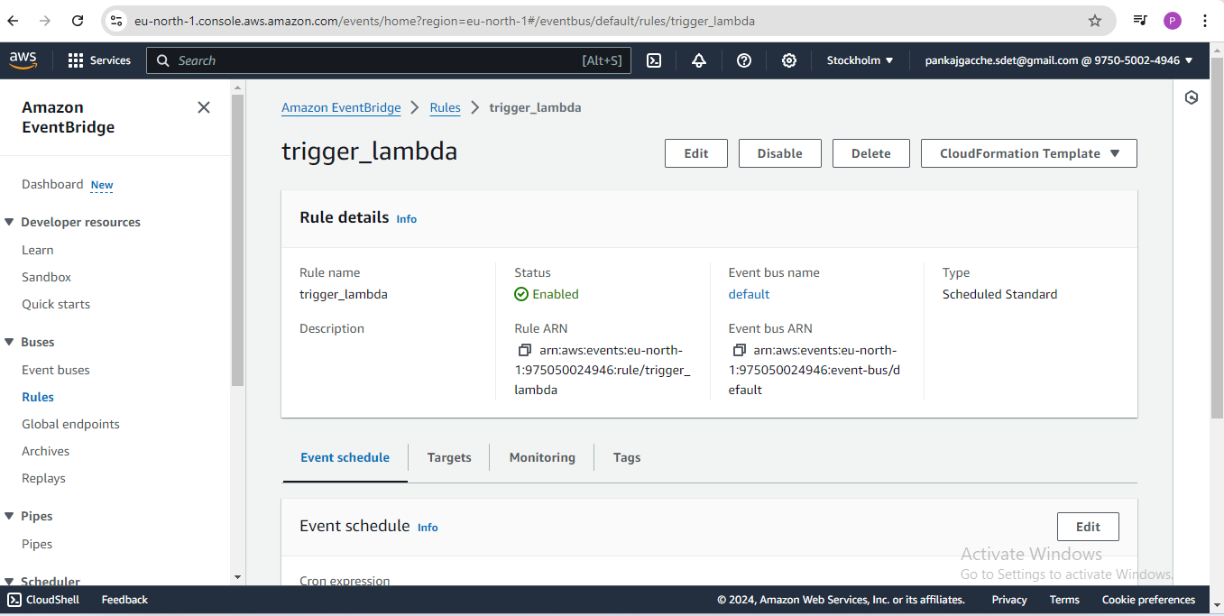

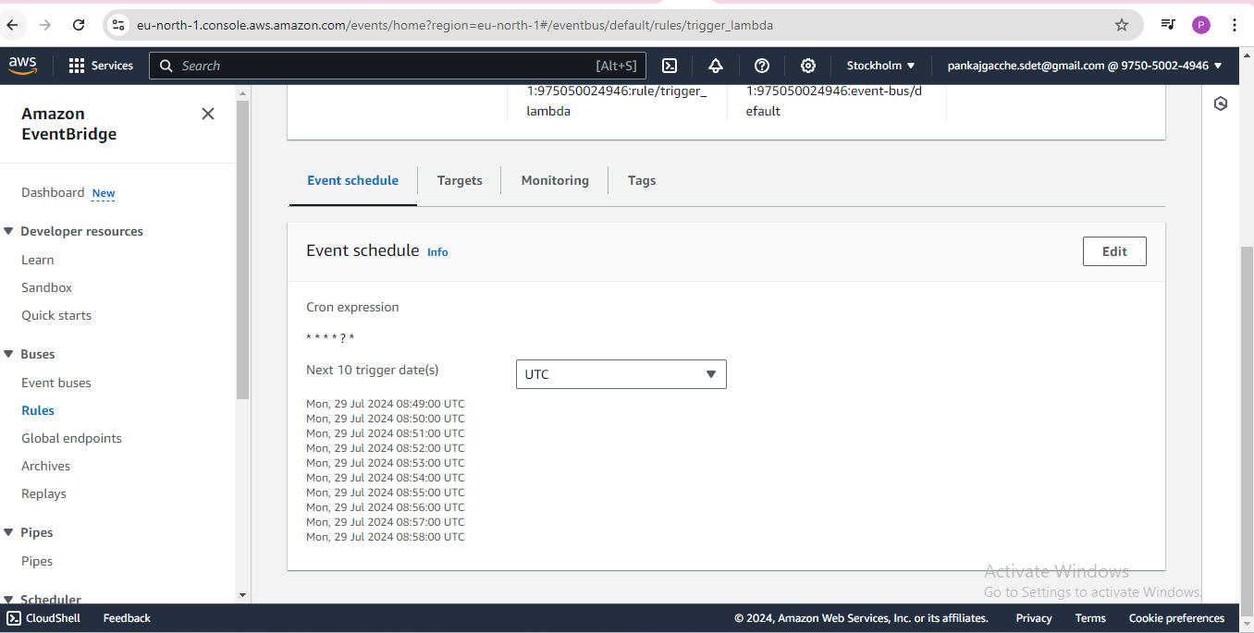

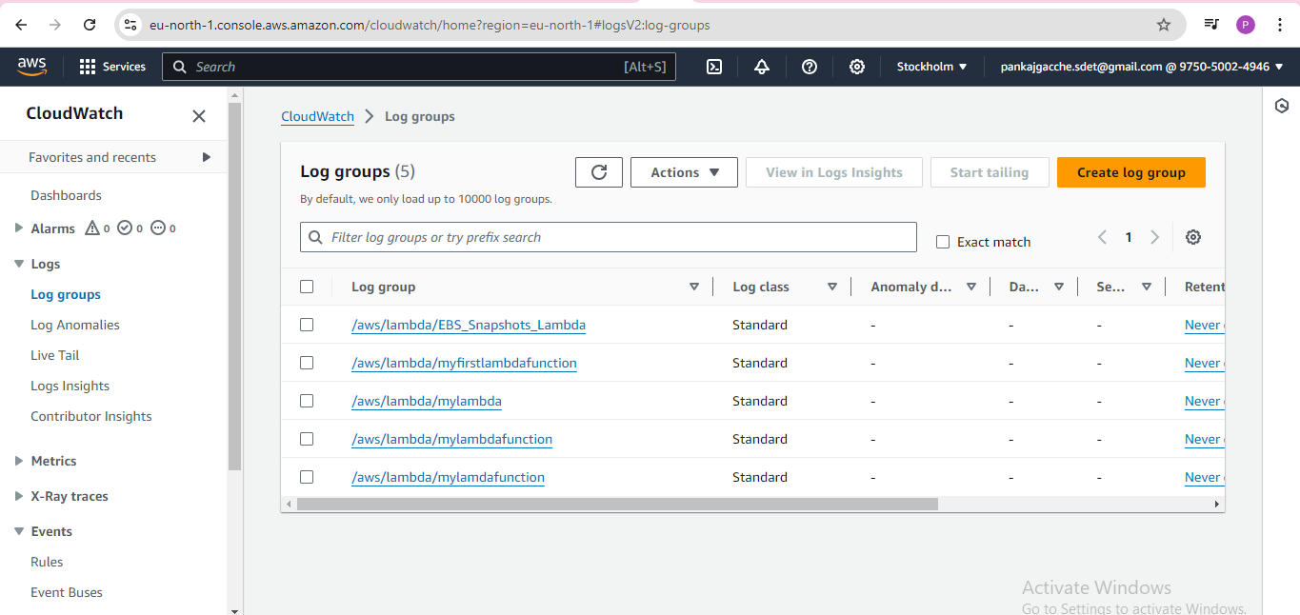

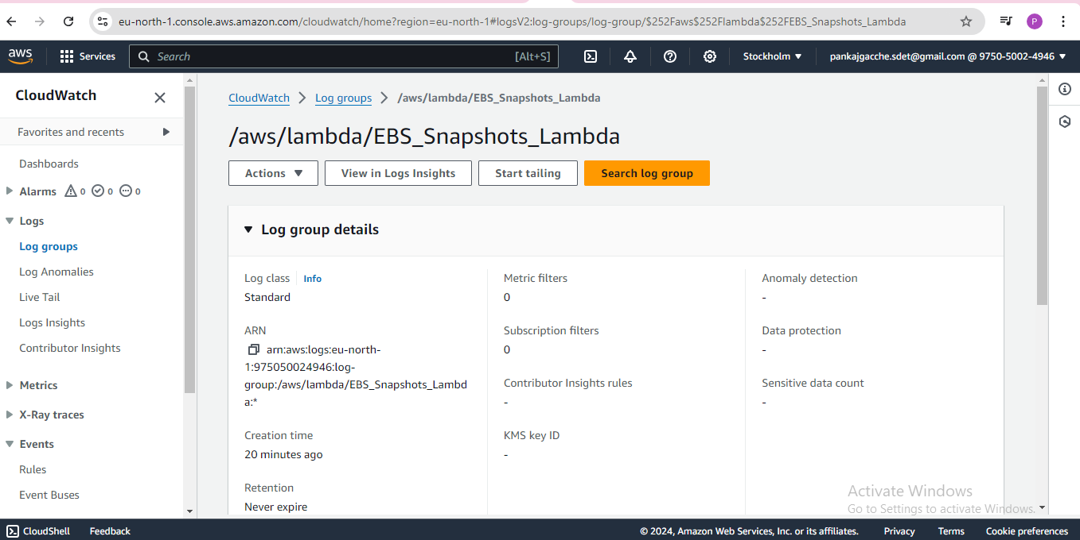

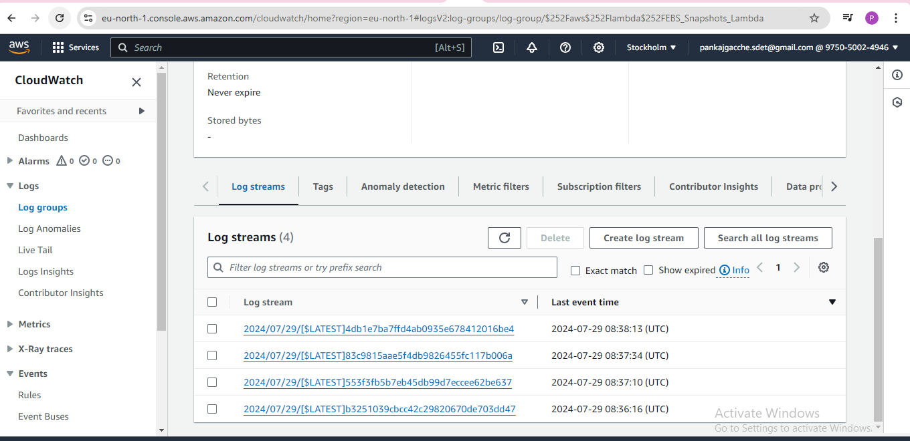

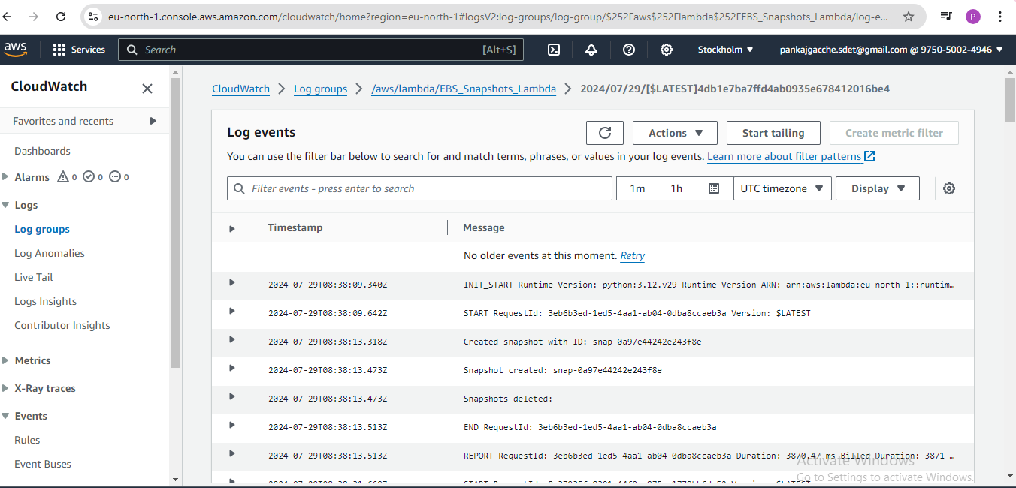

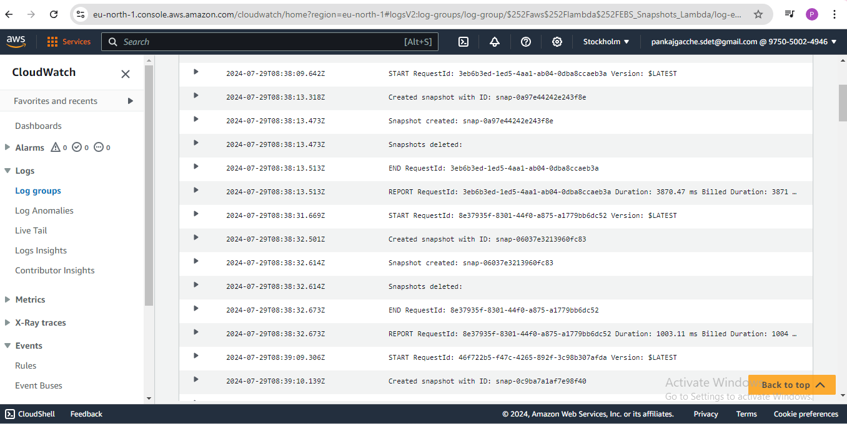

Navigated EC2 dashboard and confirmed that the snapshot is created and old snapshots are deleted.

